**e-Library Application using Java**

**by Asif Ali (22SCSE2030611)**

**Abstract:**

The rapid advancement of technology has transformed traditional libraries into digital spaces, known as e-libraries. This project focuses on the development of an E-Library Application using Java to provide users with a seamless and efficient platform for accessing and managing digital resources. The application incorporates a user-friendly interface and robust functionalities to enhance the overall library experience.

The E-Library Application is built using Java programming language and follows a client-server architecture. The back-end is implemented using Java servlets and JDBC for database connectivity, ensuring data integrity and security. The front-end utilizes JavaFX for a responsive and visually appealing user interface, making it accessible across various devices.

**Key Features:**

**User Authentication and Authorization:** The application includes a secure login system to authenticate users. Different levels of access are implemented to ensure that only authorized users can perform certain actions, such as borrowing books, accessing personal profiles, or managing the library's digital catalog.

**Digital Catalog Management:** The E-Library Application allows administrators to manage the digital catalog efficiently. They can add new books, update existing information, and remove outdated resources. Each book is associated with metadata, including title, author, publication date, and a brief description.

**User Profiles and Preferences:** Users can create and manage their profiles, enabling them to track their borrowing history, set preferences, and receive recommendations based on their reading habits. The application also provides features like book ratings and reviews to enhance user engagement.

**Search and Filter Functionality:** A powerful search engine enables users to quickly find books based on various criteria, such as title, author, genre, or keywords. Filters and sorting options enhance the search experience, making it easier for users to discover relevant resources.

**Borrowing and Returning System:** The application facilitates a smooth process for borrowing and returning digital resources. Users can check the availability of books, reserve items, and receive notifications for due dates. Automated reminders help users manage their borrowed items efficiently.

**Responsive Design:** The user interface is designed to be responsive, adapting to different screen sizes and devices. This ensures a consistent and user-friendly experience across desktops, laptops, tablets, and smartphones.

**Security Measures:** The application prioritizes data security, implementing encryption protocols for sensitive information. User authentication and authorization mechanisms protect against unauthorized access and ensure the confidentiality of user data.

In conclusion, the E-Library Application developed in Java provides a comprehensive and secure solution for managing digital resources. Its user-friendly interface and robust features aim to enhance the overall e-library experience, making it a valuable tool for both administrators and library patrons.

**Features of the E-Library App**

**Search Functionality**

Easily find specific books or browse through various genres and authors.

**Bookmarking and Note-taking**

Save your progress and jot down important insights for future reference.

**Offline Access**

Enjoy uninterrupted reading, even without an internet connection.

**User Authentication:**

Secure login and registration system for users.

User profiles with personal information and preferences.

Multi-level authentication for administrators and regular users.

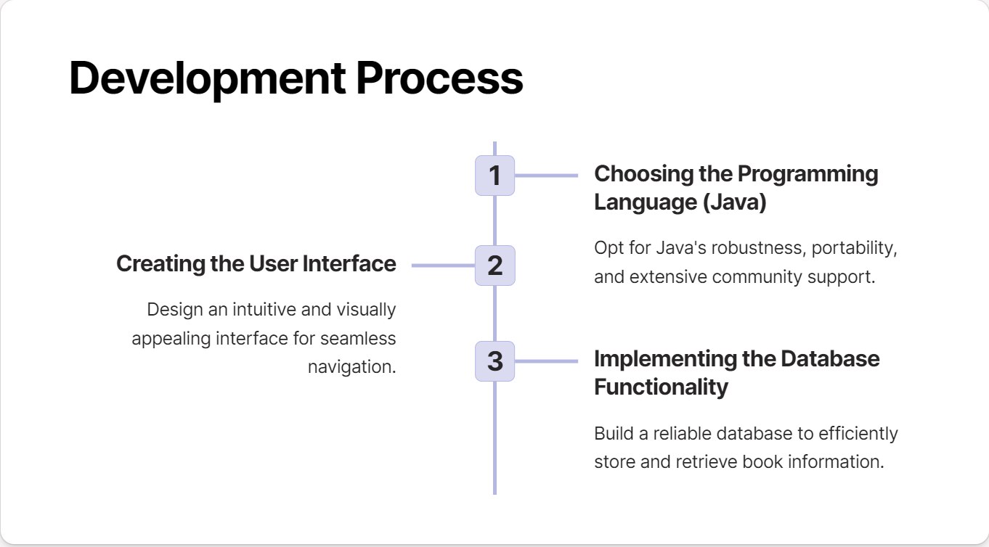

# Challenges in Building the E-Library App

**Cross-Platform Compatibility**

Evaluate and address compatibility issues across various devices and operating systems.

**Data Security and Privacy**

Implement robust security measures to protect user data and ensure privacy.

**Performance Optimization**

Optimize the app's speed and responsiveness to ensure a seamless user experience.

# Future Enhancements

#### **Integration with External Libraries and APIs**

Expand the app's capabilities by integrating with external libraries and APIs for additional content and features.

**Technology Uses in the Development of Application**

* Android Studio(Plateform where we develope the app)
* XML(Extensible Markup Language) Use to develope the User Interface
* Java Language(language which we use to code the functionality for backend process)
* MySQL(Database where we store the data of registered user)

**Java Code**

package com.example.elibrary;  
  
import androidx.appcompat.app.AppCompatActivity;  
  
import android.content.Intent;  
import android.os.Bundle;  
import android.view.View;  
import android.widget.Button;  
  
public class MainActivity extends AppCompatActivity {  
  
 @Override  
 protected void onCreate(Bundle savedInstanceState) {  
 super.onCreate(savedInstanceState);  
 setContentView(R.layout.*activity_main*);  
  
 Button ProceedButton = findViewById(R.id.*ProceedButton*);  
 Button loginButton = findViewById(R.id.*eLoginButton*);  
 Button singupButton = findViewById(R.id.*singupButton*);  
  
  
 ProceedButton.setOnClickListener(new View.OnClickListener(){  
 @Override  
 public void onClick(View v) {  
 Intent intent = new Intent(MainActivity.this,SetsActivity1.class);  
 startActivity(intent);  
 }  
 });  
 loginButton.setOnClickListener(new View.OnClickListener() {  
 @Override  
 public void onClick(View v) {  
 Intent intent2 = new Intent(MainActivity.this,LoginActivity.class);  
 startActivity(intent2);  
 }  
 });  
  
 singupButton.setOnClickListener(new View.OnClickListener() {  
 @Override  
 public void onClick(View v) {  
 Intent intent3 = new Intent(MainActivity.this,SingupActivity.class);  
 startActivity(intent3);  
 }  
 });  
  
 }  
  
 }

**XML Code**

<?xml version="1.0" encoding="utf-8"?>  
<androidx.constraintlayout.widget.ConstraintLayout xmlns:android="http://schemas.android.com/apk/res/android"  
 xmlns:app="http://schemas.android.com/apk/res-auto"  
 xmlns:tools="http://schemas.android.com/tools"  
 android:layout_width="match_parent"  
 android:layout_height="match_parent"  
 tools:context=".MainActivity">  
  
 <ImageView  
 android:id="@+id/imageView7"  
 android:layout_width="400dp"  
 android:layout_height="200dp"  
 android:layout_marginStart="4dp"  
 android:layout_marginBottom="32dp"  
 android:adjustViewBounds="false"  
 android:background="#F8F5F5"  
 android:cropToPadding="false"  
 app:layout_constraintBottom_toBottomOf="parent"  
 app:layout_constraintStart_toStartOf="parent"  
 app:layout_constraintTop_toTopOf="parent"  
 app:layout_constraintVertical_bias="0.631"  
 app:srcCompat="@drawable/laptop" />  
  
 <Button  
 android:id="@+id/ProceedButton"  
 android:layout_width="wrap_content"  
 android:layout_height="wrap_content"  
 android:fontFamily="@font/croissant_one"  
 android:text="Proceed to Learn!"  
 app:iconTint="#D16E6E"  
 app:layout_constraintBottom_toBottomOf="parent"  
 app:layout_constraintEnd_toEndOf="parent"  
 app:layout_constraintStart_toStartOf="parent"  
 app:layout_constraintTop_toBottomOf="@+id/imageView7"  
 app:layout_constraintVertical_bias="0.44"  
 tools:ignore="MissingConstraints" />  
  
 <TextView  
 android:id="@+id/textView"  
 android:layout_width="wrap_content"  
 android:layout_height="60dp"  
 android:background="#C7D1D0"  
 android:fontFamily="@font/croissant_one"  
 android:text="An investment in knowledge pays the best interest. – Benjamin Franklin"  
 android:textStyle="bold|italic"  
 app:cardCornerRadius="25dp"  
 app:cardElevation="20dp"  
 app:layout_constraintBottom_toTopOf="@+id/imageView7"  
 app:layout_constraintEnd_toEndOf="parent"  
 app:layout_constraintHorizontal_bias="0.0"  
 app:layout_constraintStart_toStartOf="parent"  
 app:layout_constraintTop_toTopOf="parent"  
 app:layout_constraintVertical_bias="0.56" />  
  
 <TextView  
 android:id="@+id/textView2"  
 android:layout_width="wrap_content"  
 android:layout_height="60dp"  
 android:background="#C7D1D0"  
 android:fontFamily="@font/croissant_one"  
 android:shadowRadius="20"  
 android:text="Live as if you were to die tomorrow. Learn as if you were to live forever.” ― Mahatma Gandhi"  
 android:textStyle="bold|italic"  
 app:layout_constraintBottom_toTopOf="@+id/imageView7"  
 app:layout_constraintEnd_toEndOf="parent"  
 app:layout_constraintHorizontal_bias="0.0"  
 app:layout_constraintStart_toStartOf="parent"  
 app:layout_constraintTop_toBottomOf="@+id/textView"  
 app:layout_constraintVertical_bias="0.684" />  
  
 <TextView  
 android:id="@+id/textView3"  
 android:layout_width="wrap_content"  
 android:layout_height="wrap_content"  
 android:layout_marginBottom="59dp"  
 android:fontFamily="@font/croissant_one"  
 android:text="eLibrary"  
 android:textSize="20sp"  
 android:textStyle="bold"  
 app:layout_constraintBottom_toTopOf="@+id/textView"  
 app:layout_constraintEnd_toEndOf="parent"  
 app:layout_constraintHorizontal_bias="0.113"  
 app:layout_constraintStart_toStartOf="parent"  
 app:layout_constraintTop_toTopOf="parent"  
 app:layout_constraintVertical_bias="0.872" />  
  
 <ImageView  
 android:id="@+id/imageView"  
 android:layout_width="95dp"  
 android:layout_height="96dp"  
 android:layout_marginEnd="44dp"  
 android:layout_marginBottom="31dp"  
 app:circularflow_radiusInDP="20"  
 app:layout_constraintBottom_toTopOf="@+id/textView"  
 app:layout_constraintEnd_toEndOf="parent"  
 app:layout_constraintHorizontal_bias="0.908"  
 app:layout_constraintStart_toEndOf="@+id/textView3"  
 app:layout_constraintTop_toTopOf="parent"  
 app:layout_constraintVertical_bias="1.0"  
 app:srcCompat="@drawable/brain" />  
  
 <Button  
 android:id="@+id/singupButton"  
 android:layout_width="wrap_content"  
 android:layout_height="wrap_content"  
 android:layout_marginBottom="92dp"  
 android:text="SingUp"  
 app:layout_constraintBottom_toBottomOf="parent"  
 app:layout_constraintEnd_toEndOf="parent"  
 app:layout_constraintHorizontal_bias="0.2"  
 app:layout_constraintStart_toEndOf="@+id/ProceedButton" />  
  
 <Button  
 android:id="@+id/eLoginButton"  
 android:layout_width="wrap_content"  
 android:layout_height="wrap_content"  
 android:layout_marginBottom="92dp"  
 android:text="LogIn"  
 app:layout_constraintBottom_toBottomOf="parent"  
 app:layout_constraintEnd_toStartOf="@+id/ProceedButton"  
 app:layout_constraintHorizontal_bias="0.615"  
 app:layout_constraintStart_toStartOf="parent" />  
  
</androidx.constraintlayout.widget.ConstraintLayout>

**OUTPUT**

